**Assignment 2**

**Process Management**

1. List out highest priority process in the system.

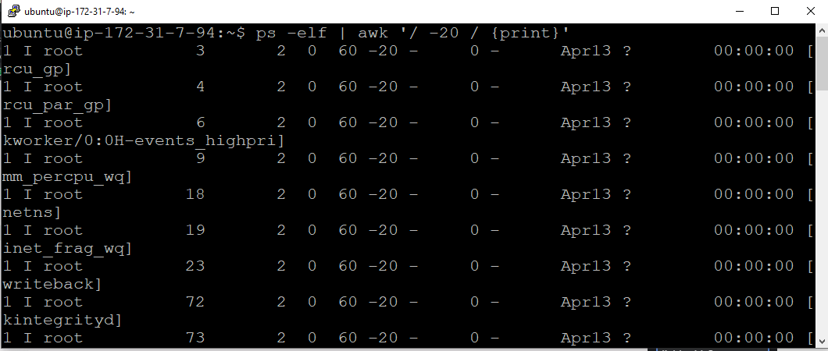

Commands:

ps :- shows the linux process

awk ‘/ -20 / ‘{print}’ – used for shows processes has value -20 .

2) Open terminal with 2 tabs or sessions  
    a)  run command "vmstat 1"

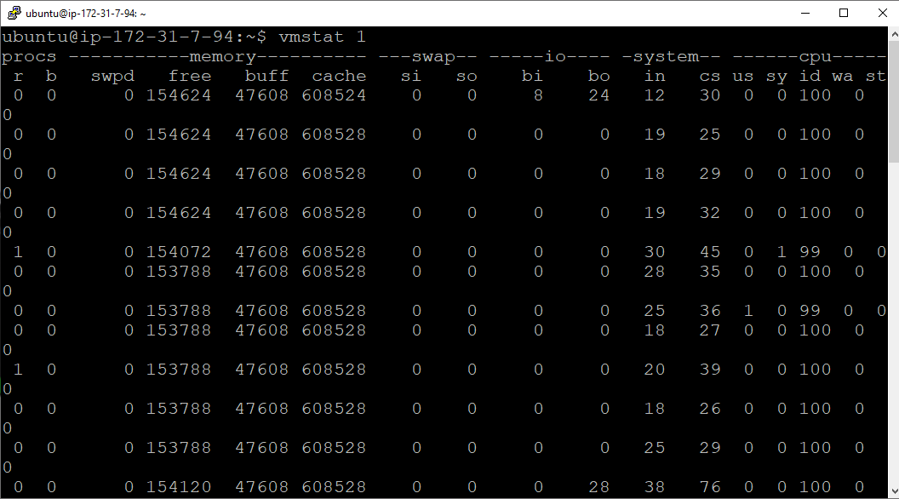

Commands:

vmstat 1 :- shows the running process by 1 sec.

b) Switch to another tab,  pause  running vmstat command for few seconds and resume it again.

use appropriate SIGNALS to do this activity.

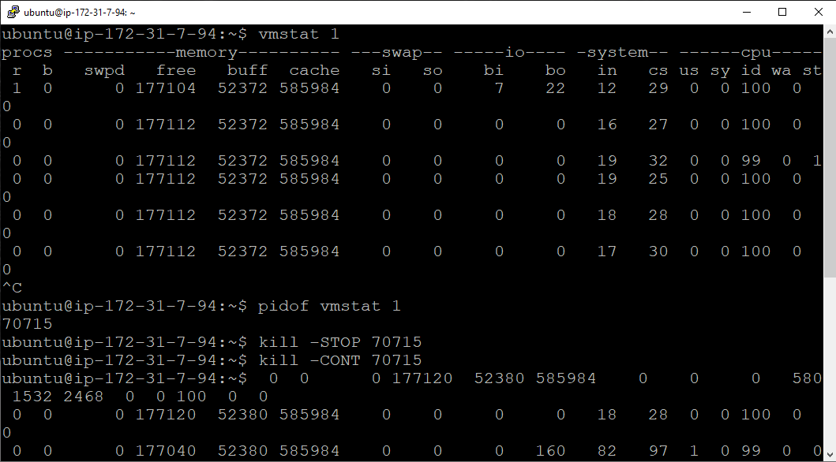

Command :

pidof vmstat 1 :- find the PID of process

kill –STOP 70715 :- pause the running process

kill –CONT 70715 :- resume the running process

1. Find the process which is sleeping in "wait" state.

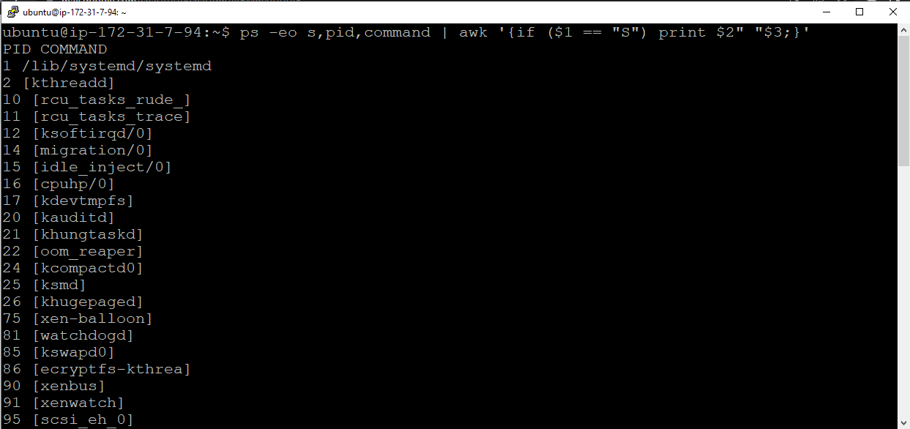

Command :

ps -C sleep :- Find the sleeping process.